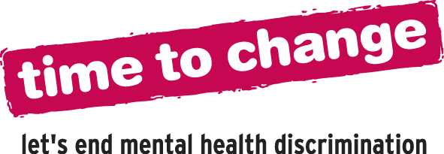


Time to Talk Day 4th February 2016
Assembly Guidance Notes for Facilitators
Time to Talk Day aims to get the nation talking about mental health. Talking about mental health helps break down stigma and promotes understanding and awareness, for the benefit of everyone. We hope this assembly helps you talk about mental health with your students and shape a stigma free future. The assembly is designed to last 15 minutes long (for additional activities please see www.time-to-change.org.uk/teachers). You will need the powerpoint slides, a projector and sound facilities.
Minutes 1 – 2
Slide 2: Show this film - www.youtube.com/watch?v=irADsjrhljI
Minutes 3 - 5
Slide 3: Turn to the person next to you and discuss
- What did you think of the film?
- What do you think the message is?
Minutes 5 – 6
Slide 3: Explain that mental health can feel like a tricky topic and we might not feel that we know much about it. We don’t need to understand anything about mental health problems to look out for our friends. Going through any illness can be difficult but labels such as “attention seeking” and “dramatic” can make it that much harder and prevent someone from getting the help that they need.
Minute 7
Slide 3: Explain Nikki’s story: Nikki started to experience symptoms of a mental health problem when she was 14. When people saw the scars on her arms they called her an attention seeker and a weirdo. Some people thought it was contagious and would just stay away. Looking back at that time, Nikki says ‘When I was at my worst, my teachers and peers didn't understand what I was going through and the issue was never talked about. I think if people had talked about it like this when I was at school, I wouldn't have felt so alone.
Minutes 8 – 9
Slide 4: 1 in 10 young people will experience a mental health problem. Mental health problems can affect anyone irrespective of age, race or gender. You can recover from mental health problems, just as you can from physical health problems.
Here is more information (from a 2013 Time to Change online survey of young people) which you may wish to share at this point
Young People report that they have experienced stigma from:
  - friends (65%)
  - parents (50%)
  - boyfriends and girlfriends (45%)
  - teachers (43%)
- 28% said negative reactions from others had made them want to give up on life
- 69% said that fear of stigma has prevented them from telling a friend about their mental health problem
- 50% said it had stopped them applying for a job
- 30% said that it had stopped them applying for or taking up a place at college or university
Minutes 10 – 13
Slide 5: Explain that when it comes to mental health problems, the small things make a big difference. You don’t have to be an expert to help someone with a mental health problem, just being there can help. Ask the group to chat to the person next to them about the little things they could do to help a friend or to make the school feel like a less judgemental place.
Minute 14
Slide 5: Show the tips on the screen (add some of your own if you’d like)
Minute 15
Slide 6: Explain that today is Time to Talk Day and that all over the country people are talking about mental health. Encourage the group to think about the small things they discussed and to try and have one conversation or do one thing that could help end the stigma around mental health. Time to Change is England’s biggest mental health anti-stigma and discrimination campaign and it is their aim to break the silence around mental health and end the common misconceptions. You can log your conversation at the Time to Change website and find out more about the campaign.

